Johns Hopkins Medicine Health Records in Health App on iPhone
Patient Quick Start Guide
Last Revised December 4, 2018

Table of Contents
Getting Started 3
Introduction 4
Step-By-Step Instructions: 5

Getting Started
This Quick Start Guide provides you with step-by-step instructions for getting started with Apple® Health app on Apple® iPhone®.

Introduction
Starting March 29, 2018, patients from any of Johns Hopkins Medicine and 38 other institutions can view their medical records right from their iPhone® (running iOS 11.3 or later). The updated “Health Records” section within the Apple® Health app helps consumers see medical information from various institutions organized into one view and receive notifications when their data is updated. This information can help patients better understand their health history, have informed conversations with physicians and family members, and make future decisions. Health Records data is encrypted and protected with the user’s iPhone passcode.

Step-By-Step Instructions:

- To ensure that you are updated to the latest iOS (11.3 or later), open Settings > General > Software Update
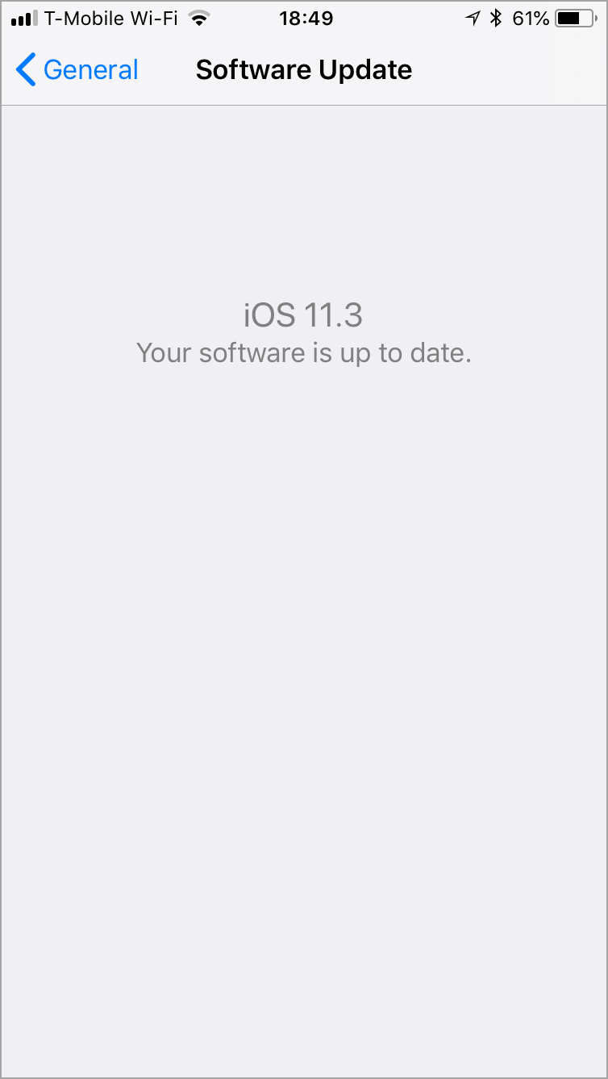
- From the home screen, tap the Health App.
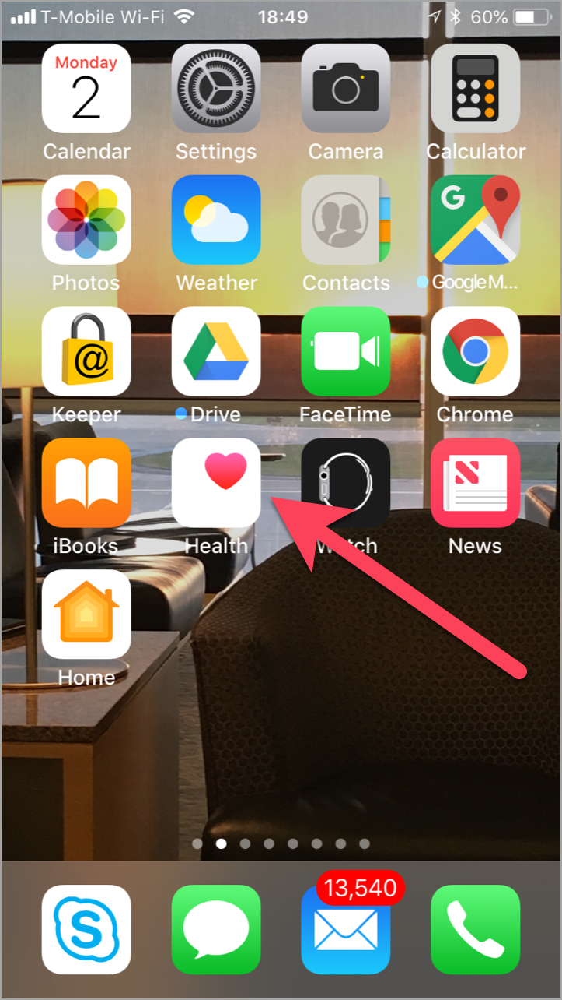
- Navigate to the Health Data activity. Tap Health Records.
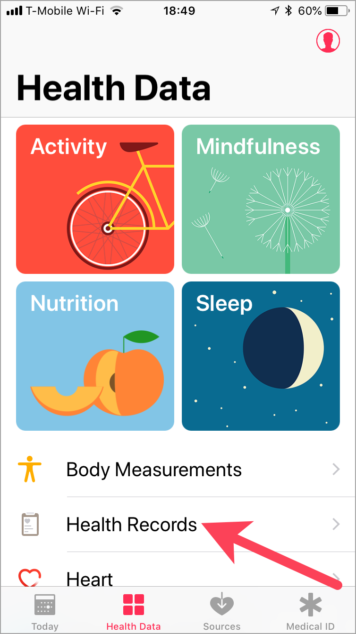
- Tap Get Started.
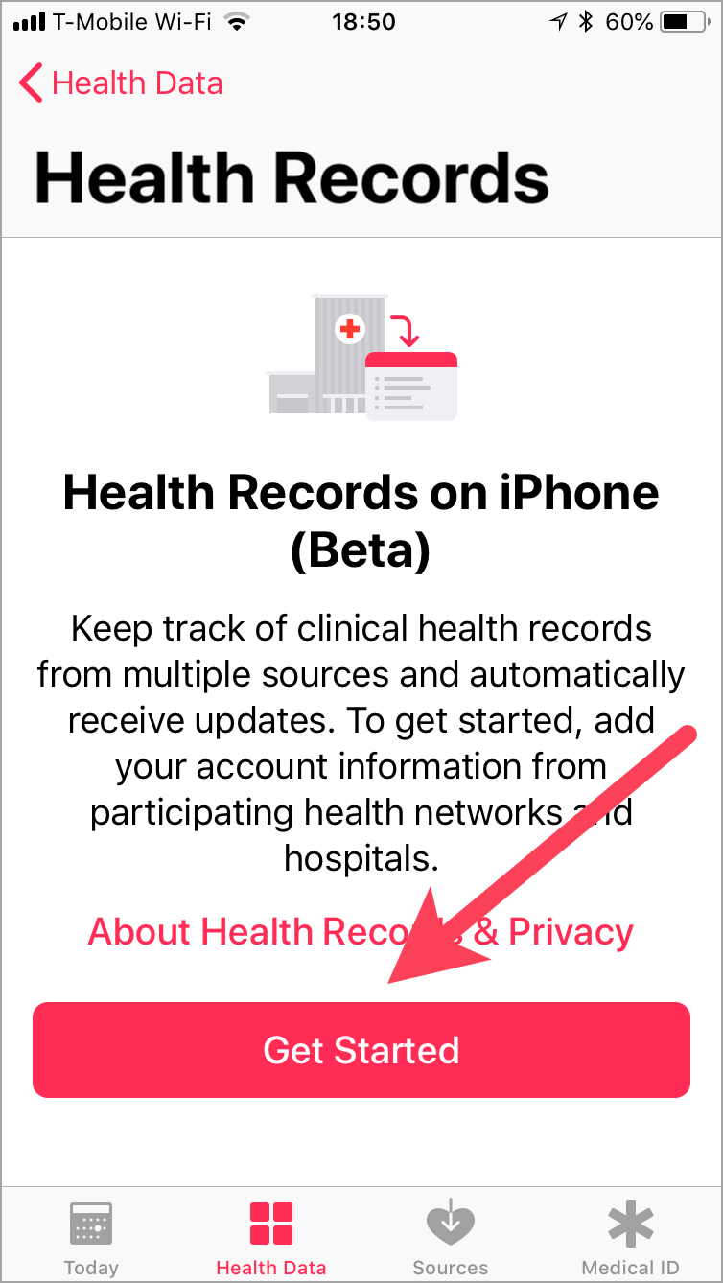
- Select any entities at Johns Hopkins Medicine where you have been seen (Johns Hopkins Hospital, Bayview Medical Center, Sibley Memorial Hospital, Suburban Hospital, Johns Hopkins Outpatient Center, Johns Hopkins Community Physicians, Howard County General Hospital).
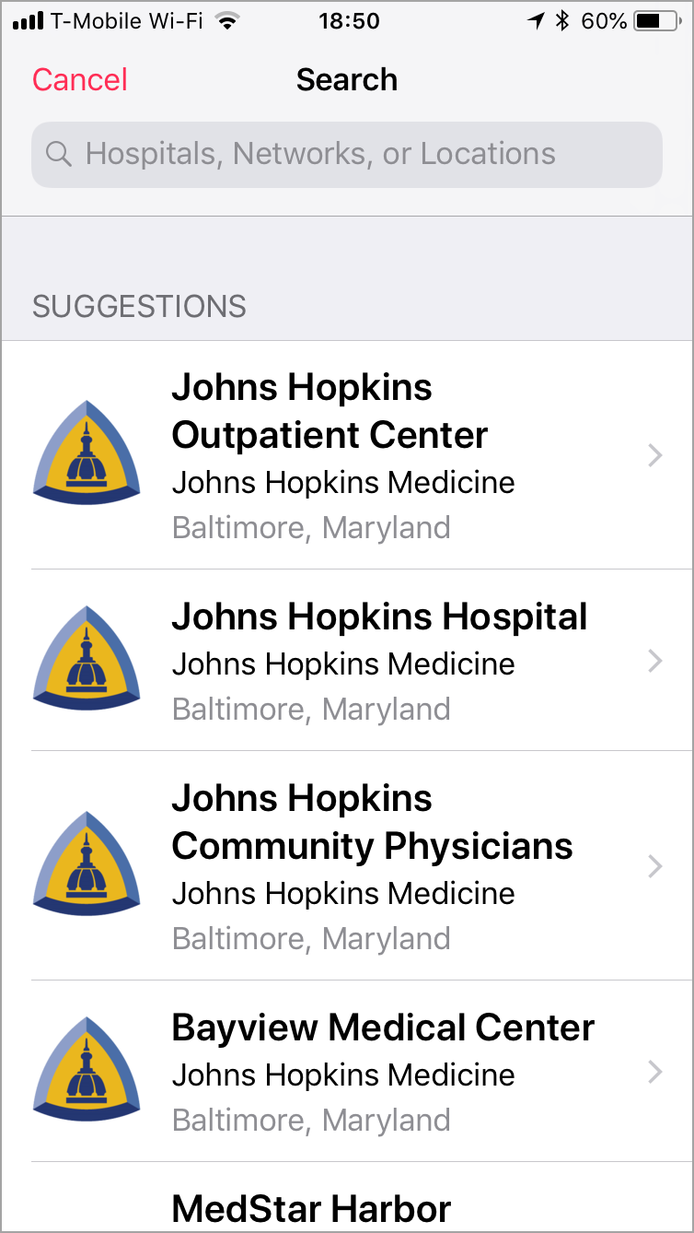
- You will be prompted to connect to the Johns Hopkins Medicine MyChart website.
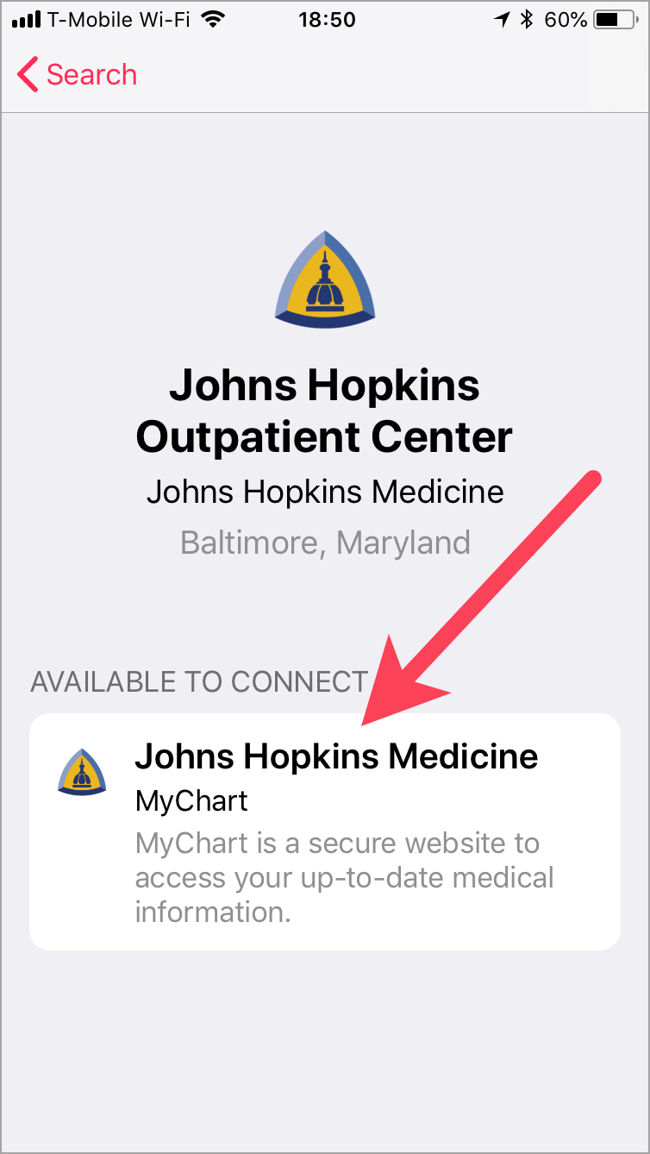
- Enter your Johns Hopkins Medicine MyChart credentials, and tap Sign In.
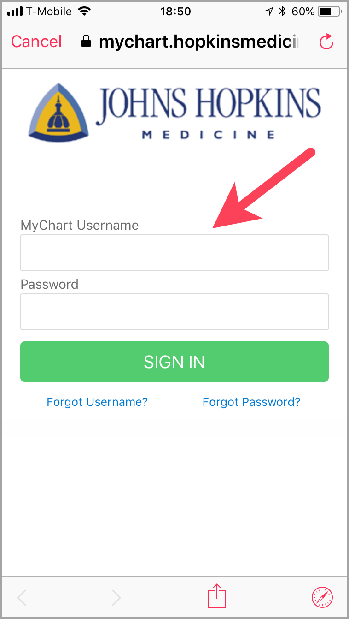
- Allow Apple® access to your MyChart by tapping Allow Access (this will link your MyChart to the Health app).
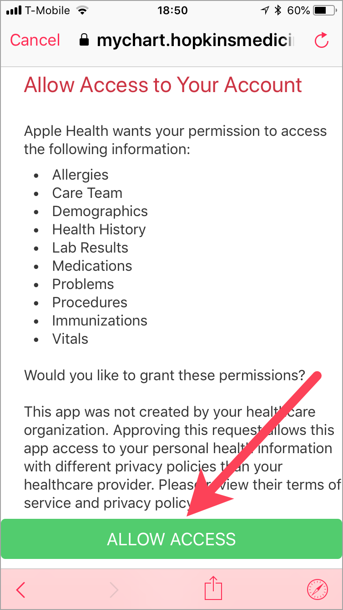
- Confirm that your account is added by tapping Done.
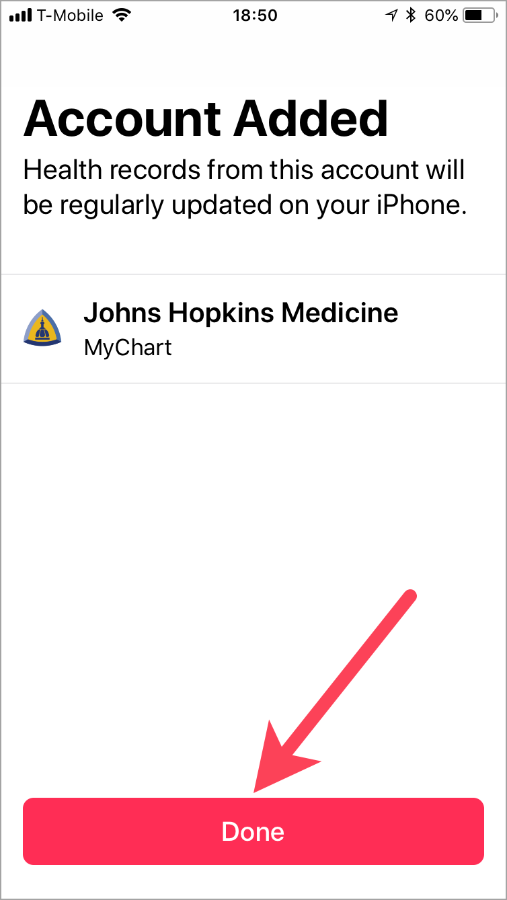
- Congratulations! Your MyChart is now linked to the Health app. You can view your Allergies, Clinical Vitals, Conditions, Immunizations, Lab Results, Medications, Procedures, and your demographic information. Tap on a section to view detailed information.
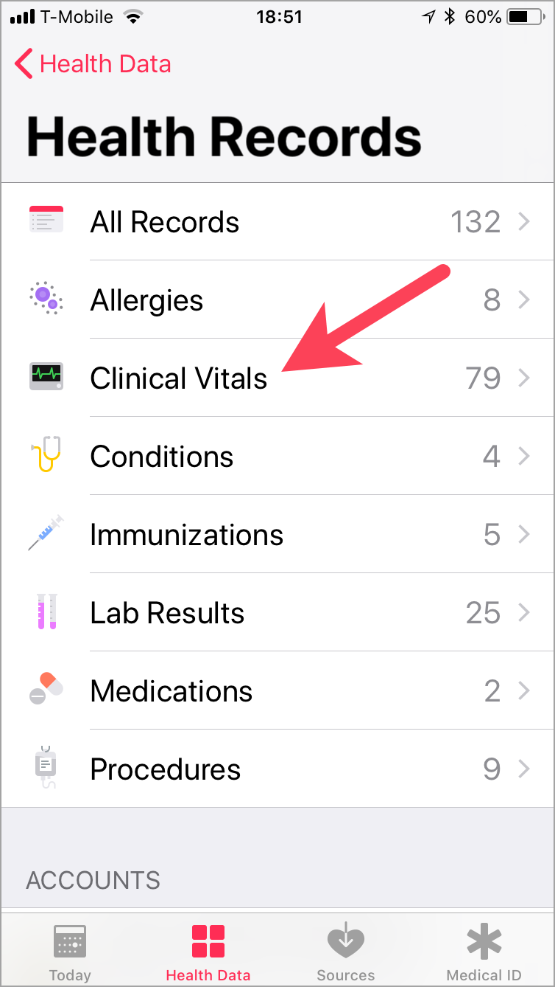
- Example of the Clinical Vitals screen:
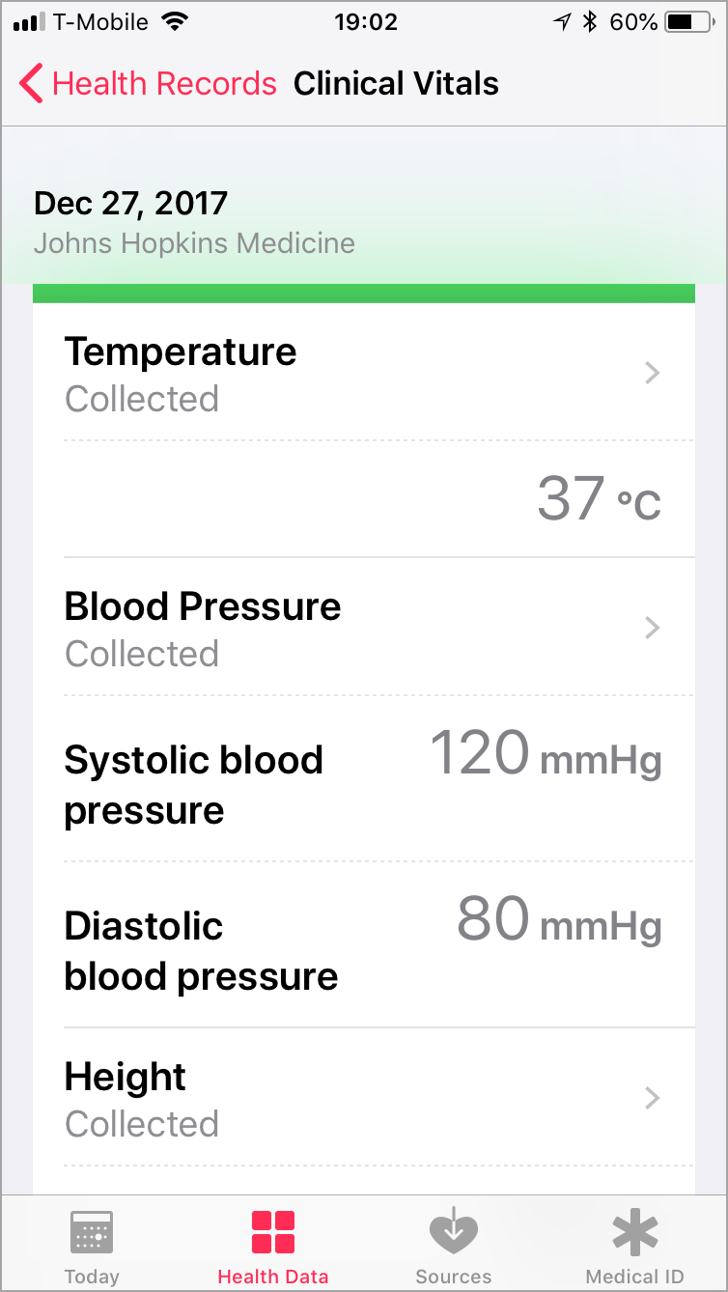
NOTES

© 2017 Epic Systems Corporation. All rights reserved. PROPRIETARY INFORMATION - This item and its contents may not be accessed, used, modified, reproduced, performed, displayed, distributed or disclosed unless and only to the extent expressly authorized by an agreement with Epic. This item is a Commercial Item, as that term is defined at 48 C.F.R. Sec. 2.101. It contains trade secrets and commercial information that are confidential, privileged and exempt from disclosure under the Freedom of Information Act and prohibited from disclosure under the Trade Secrets Act. After Visit Summary, Analyst, App Orchard, ASAP, Beaker, BedTime, Bones, Break-the-Glass, Caboodle, Cadence, Canto, Care Everywhere, Charge Router, Chronicles, Clarity, Cogito ergo sum, Cohort, Colleague, Community Connect, Cupid, Epic, EpicCare, EpicCare Link, Epicenter, Epic Earth, EpicLink, EpicWeb, Good Better Best, Grand Central, Haiku, Happy Together, Healthy People, Healthy Planet, Hyperspace, Identity, IntraConnect, Kaleidoscope, Limerick, Lucy, MyChart, OpTime, OutReach, Patients Like Mine, Phoenix, Powered by Epic, Prelude, Radar, RedAlert, Resolute, Revenue Guardian, Rover, SmartForms, Sonnet, Stork, Tapestry, Trove, Welcome, Willow, Wisdom, and With the Patient at the Heart are registered trademarks, trademarks or service marks of Epic Systems Corporation in the United States of America and/or other countries. Other company, product and service names referenced herein may be trademarks or service marks of their respective owners. U.S. and international patents issued and pending.
This guide is based on Epic 2017.
Apple, the Apple logo, and iPhone are trademarks of Apple Inc., registered in the U.S. and other countries.

